Prerequisite :

* EC2 Launch Template

Steps To create auto-scaling with load balancer:

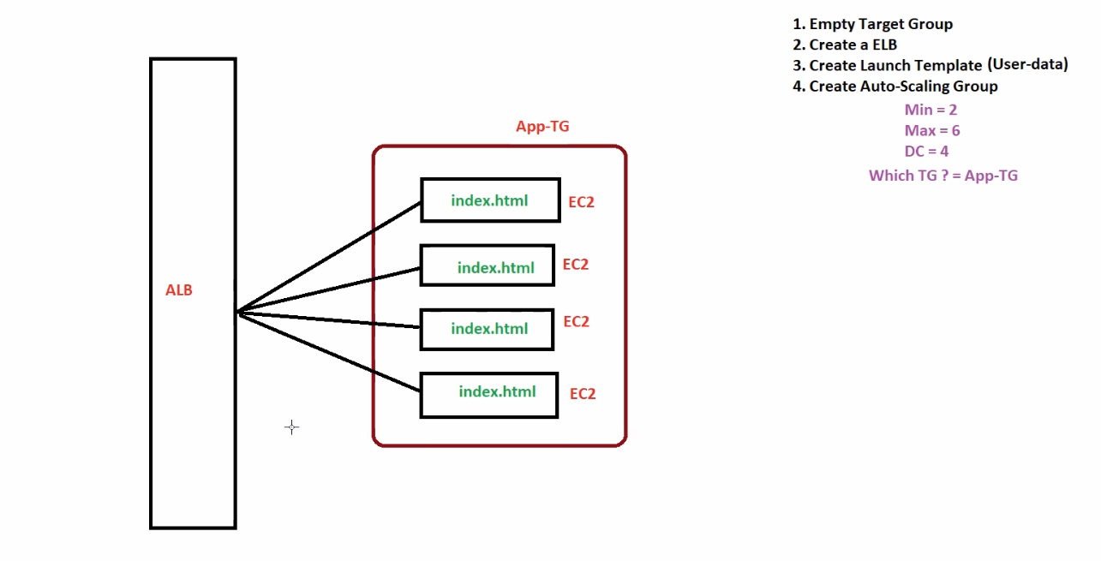

1. Create empty target group.  
   Here Auto-Scaling group will create ec2 instance and add automatically in target group.
2. Create Load Balancer.
3. Create Launch Template.
4. Create Auto-Scaling group.

Min = 2, 🡺 after in scaling minimum 2 ec2will remains.

Desire = 4, 🡺 initially 4 ec2 instance got created.

Max = 6 🡺 after out scaling maximum 6 ec2 instance got created.

Target group = mention target group